|  |
| --- |
|  |
| Test Plan |
|  |
|  |
|  |
|  |

|  |
| --- |
|  |

Contents

Test Plan 2

Main Menu 2

Instructions Menu 2

Game Menu 3

Appendix 5

Appendix 1 5

Appendix 2 5

Appendix 3 6

Appendix 4 7

Appendix 5 8

Appendix 6 9

Appendix 7 10

Appendix 8 11

# Test Plan

## Main Menu

|  |  |  |  |  |
| --- | --- | --- | --- | --- |
| What is being tested? | Testing Method | Expected Result | Actual Result | Actual Result Evidence |
| Screen Loads | Run program | Main menu loads showing: title and two buttons | Main menu loads showing: title and two buttons | Appendix 1 |
| Instruction Button | Button Pressed | Once button pressed Instructions menu load and main menu closes | Once button pressed Instructions menus loaded and main menu closed | Appendix 2 |
| Start Game Button | Button Pressed | Once button pressed Game menu load and main menu closes | Once button pressed Game menu loaded and main menu closed | Appendix 3 |

## Instructions Menu

|  |  |  |  |  |
| --- | --- | --- | --- | --- |
| What is being tested? | Testing Method | Expected Result | Actual Result | Actual Result Evidence |
| Text Viewable | Program run | The text is expected to be visible and within the boundaries of the text area | The text was visible and within the boundaries of the text area | Appendix 2 |
| << Back to main menu button | Button pressed | The button will close the Instructions menu and open the main menu | The button will closed the Instructions menu and opened the main menu | Appendix 1 |

## Game Menu

|  |  |  |  |  |
| --- | --- | --- | --- | --- |
| What is being tested? | Testing Method | Expected Result | Actual Result | Actual Result Evidence |
| Game tiles clickable | Tile button clicked | When player clicks on tile it changes to ‘X’ | When player clicked on tile it changed to ‘X’ | Appendix 4 |
| Computer AI | Tile button clicked by human player | After human player has clicked a tile the computer will chose a tile to click | After human player clicked a tile the computer chose a tile to click | Appendix 4 |
| Computer Win | Play a game | A game will be played were the computer will win and an alert message will appear | A game was played resulting in the computer win. A messaged appeared saying ‘The computer wins!’ | Appendix 5 |
| Score update | Play a game | A game will be played resulting in the computer winning. The score tile will update the computer score to 1. | A game was played resulting in the computer winning. The score tile updated the computer score to 1. | Appendix 6 |
| Tie | Play a game | A game will be played were the game will result in a tie and an alert message will appear | A game was played resulting in no winner. A messaged appeared saying ‘Tie!’ | Appendix 8 |
| Game tiles once clicked are locked | Play a game | A game will be played to test all tiles become locked | A game was played until the end and all button became locked after being clicked | Appendix 6 |
| Back to main menu button | ‘Back to main menu’ button clicked | The button will close the Instructions menu and open the main menu | The button will closed the Instructions menu and opened the main menu | Appendix 1 |
| Restart Game button | ‘Restart Game’ button clicked |  |  | Appendix 7 |

# Appendix

## Appendix 1

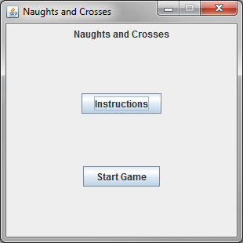

## Appendix 2

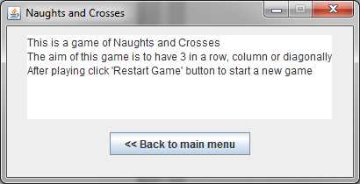

## Appendix 3

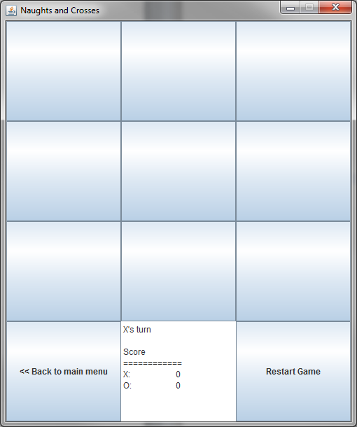

## Appendix 4

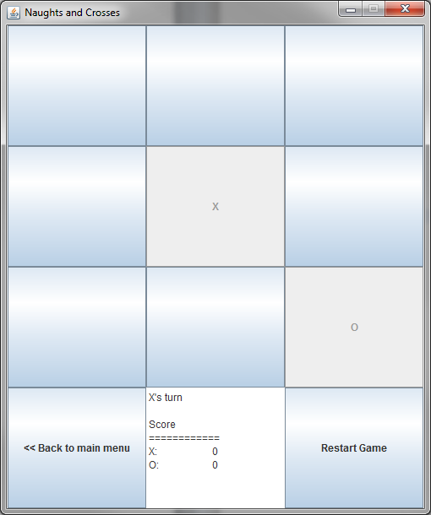

## Appendix 5

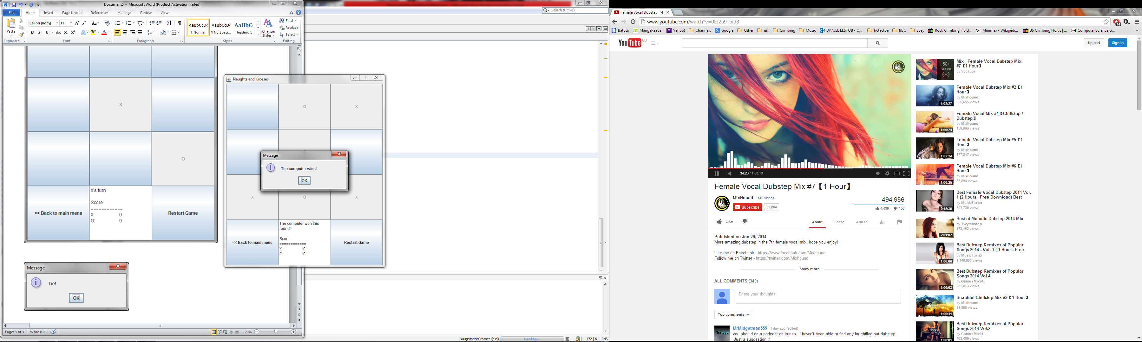

## Appendix 6

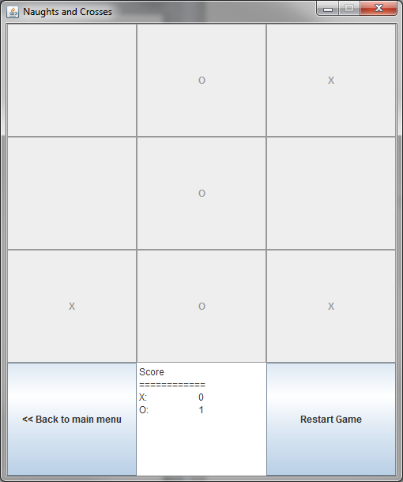

## Appendix 7

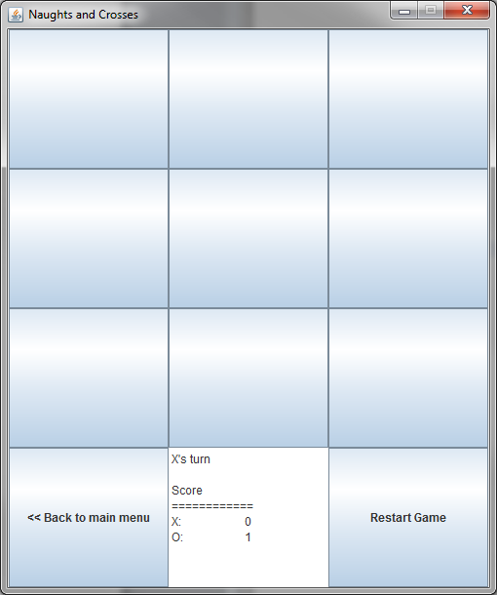

## Appendix 8

